**Kathmandu Bernhardt College**

**(Affiliated to Tribhuvan University)**



**A Project Proposal**

**On**

**“Apocalypse”**

**Submitted by**

**Bishwas Shrestha**

**4610524**

**Submitted to**

***Department of Computer Application***

**Kathmandu BernHardt College**

**Bafal, Kathmandu, Nepal**

**February, 2022**

Table of Contents

Title Page No

1. Introduction 1

2. Problem Statements 1

3. Objectives 1

4. Scope and limitation 1

4.1 Scope 1

4.2 Limitation 1

5. Methodology 2

A. Requirement identification 2

I. Study of existing system 2

II. Literature review 3

III. Requirement Analysis 4

B. Feasibility Study 5

I. Technical feasibility 5

II. Economic Feasibility 5

III. Operational feasibility 5

C. High level decision of system 6

I. Working mechanism 6

II. Algorithms 6

6.Gantt Chart 7

7.Expected Outcome 7

8.References 8

# 

# Introduction

Apocalypse, a 2d game for windows-based operating system based on an android game. In Apocalypse player has to stop enemies from reaching the end using their heroes collecting coins stopping enemies. Defeating enemies are rewarded with coins. Powerful heroes cost more coins.

# Problem Statements

Just about all of the most popular video games have some requirement for problem-solving and/or critical thinking. This promotes adaptability and cognitive flexibility. These are really important skills to have in any kind of problem-solving task.

Studies have indicated that compared to non-gamers, experienced gamers are better at: tracking objects; keeping track of several objects simultaneously; filtering out irrelevant information; switching from task to task; detecting changes in visual layouts; and 3D mental rotation.

# Objectives

The major objectives of the project are:

1. To develop a game for entertainment purpose.
2. To demonstrate unique skills in designing, emerging as well as project management so as to expand modified video games in support of diverse users.

# Scope and limitation

## 4.1 Scope

When people talk about video games development, we often read that the rate of project abandonment is very high and its true; it’s fun, attractive, with the right functionality, and with enough marketing to be seen among the many that are published every day.

## 4.2 Limitation

1. System to require DirectX: Version 11 or higher.
2. System should include OpenCL 4-compliant onboard graphics or higher.

# Methodology

An iterative approach to project management and software development that helps deliver value to their audience faster and with fewer headaches. Instead of betting everything on a launch, an agile process delivers work in small, but consumable, increments. Requirements, plans, and results are evaluated continuously so developer have a natural mechanism for responding to change quickly.

## Requirement identification

## Study of existing system

According to Aura Hernández-Sabaté1, Meritxell Joanpere1, Núria Gorgorió1, Lluís Albarracín1 1* Universität Autònoma de Barcelona, in this study we have used a video game of the Tower Defense genre to detect the game processes associated with mathematical concepts and procedures relevant to students aged from 10 to 12years. The main goal of the study is using this characterization of the students’ gameplay as a problem-solving activity to identify mathematical learning opportunities that can be promoted while playing.

The video game used in the qualitative study is Vector Tower Defense 2, by Candystand.I thas been accessible on the web since 2008. The aesthetics of the game is neutral, and there are no elements of violence, making it suitable for students from the age of 10. In this game, the enemy has to move along a specific path, and players have a large variety of towers, upgrades and bonus  
points, prompting them to exploit their strategic skills to the limit. One of the features of this video game design is that it includes bonus points at the end of each wave of enemy attack – a specific percentage of the banked money – so that choosing the right moment to invest in new towers is yet another element of the game’s strategic aspects.

The game provides players with information on different levels. The panel containing the most information is the game map, which takes up the whole central part. This area shows the path the enemy must take the position of the towers, the shots taken from the towers and the bonus objects on them.  
General information is provided at the top of the screen, such as the number of the next enemy wave, available funds, the interest percentage they generate and the lives remaining. The different towers that can be used at each moment are shown on the right, including a description of them and details of the enemy. Figure 2 displays a description of one of the towers, showing the cost, the  
damage it inflicts in each attack and the bonus points for the various types of towers expressed as percentages [1]

## Literature review

Tower Defense is a sub–genre of real–time strategy video games. The goal is to prevent enemy units, who arrive in waves, from crossing the map and attacking our base. To achieve this, defense towers have to be built which can assault enemy units as they pass. Funds are earned for eliminating each enemy unit, and these must be used to build or reinforce towers, so that strategic considerations are based on the choice and placement of the towers and resource management. There is a great variety of games in this genre but, in all of them, both the enemies and the defensive towers have different offensive and defensive skills, and each has a different cost. The video game used in the qualitative study is Vector Tower Defense 2, by Candystand. It has been accessible on the web since 2008. The aesthetics of the game is neutral, and there are no elements of violence, making it suitable for students from the age of 10. In this game, the enemy  
has to move along a specific path, and players have a large variety of towers, upgrades and bonus points, prompting them to exploit their strategic skills to the limit. One of the features of this video game design is that it includes bonus points at the end of each wave of enemy attack – a specific percentage of the banked money – so that choosing the right moment to invest in new towers is yet another element of the game’s strategic aspects.[2]

According to Adrian Rusu, Robert Russell, Edward Burns, and Andrew Fabian from  
Department of Computer Science, Rowan University Younger audiences find our real-time strategy, tower-defense game very appealing, as it is engaging, immersive, and fun. We use metaphors to simulate similar strategies that would be used in a real software project to perform software maintenance. Other educational software engineering games simulate general aspects of software engineering from a project management perspective.[3]

Kebritchi, Hirumi and Bai used a commercial video game designed specifically to foster the learning of mathematics. The latter is based on the formulation of mathematical questions and problems akin to those commonly used in classrooms.[4]  
Van den Heuvel–Panhuizen, Kolovou and Robitzsch used a dynamic online game designed to exercise early algebra problem solving. This video game proposes a sequence of problems to the students and monitors their progress. Their results show that online work improves their marks in problem–solving, but does so by using strategies that are approached differently in classroom environments, such as in trial–and–error strategy. [5]

Chow, Woodford and Maes, used an online version of the game “Deal or not deal” which is similar to tower defense with similar concept and confirm that students improve their knowledge on expected values in an introductory statistics course at the same time as they improve their overall  
ability to process information and make logical decisions.[6]

## Requirement Analysis

Requirement analysis results in the specification of operational characteristics of software: indicates interface of software with other system elements and establishes constrains the software must meet. The requirement analysis is mainly categorized into two types functional and non-functional:

## Functional requirements

* The system should be running on Microsoft 64bit Windows 7 or higher.
* The system processor should at least: 64bit Intel compatible Dual Core CPU or higher.
* The system should have memory of at least 2 GB RAM or higher.
* System Graphics: OpenGL 4-compliant onboard graphics or higher.
* At least 500mb of hard disk storage capacity.

## Non-functional requirements

* No personal information required to gain access of the game.
* No special permission from admin is required.
* No any payments system included to make it economically feasible.

## Feasibility Study

## Technical feasibility

Technical feasibility assesses the current resources (hardware and software) and  
technologies, which are required to accomplish user requirements. It requires a computer with a windows-based operating system installed. Today every organization has computer, so it is not an extra cost. Performance may differ from the specifications of the machines.

## Economic Feasibility

No any payment features are included since it is created using free tools and applications. Completely free in nature.

## Operational feasibility

Since it is created using all the free tools and applications it will be available to all the users that are interested in games.

## High level decision of system

## Working mechanism

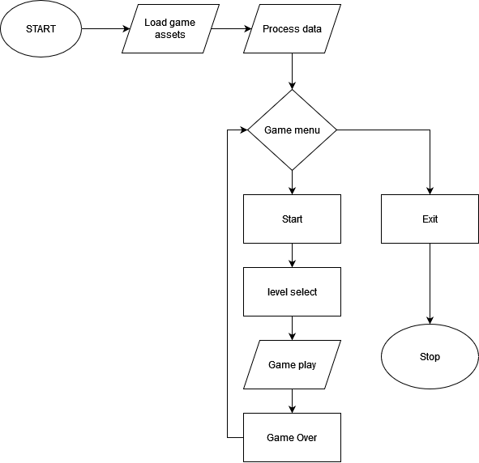

Figure 2 Flowchart

## Algorithms

## Algorithm game progression

Progression of enemies in games are done using a process to count health of enemy each spawn. Defeating more enemy increases the difficulty of level. Difficulty level increment results in giving enemy more health, faster spawn rate, increase number of enemies each spawn, increase enemy speed in each spawn. These are steps to keep the track of enemy progression in the game.

# 6.Gantt Chart

It is prepared using application such as Microsoft Word and Microsoft Excel.

Figure 3 Gantt Chart

# 7.Expected Outcome

When the application is executed, the main menu is expected to pop up with different options regarding the game. When the game is started assets are expected process and load. After the assets are loaded, the enemies are supposed to spawn and player are started with few coins for their heroes and heroes are expected to target the zombie in their range and finish them off to get more coins. More coins = more powerful heroes with more range and fire rate.

# 8.References

[1]<https://www.researchgate.net/profile/Lluis-Albarracin/publication/286913995_Mathematics_learning_opportunities_when_playing_a_Tower_Defense_Game/links/567331f108ae1557cf494de2/Mathematics-learning-opportunities-when-playing-a-Tower-Defense-Game.pdf>

[2]<https://www.researchgate.net/profile/Lluis-Albarracin/publication/286913995_Mathematics_learning_opportunities_when_playing_a_Tower_Defense_Game/links/567331f108ae1557cf494de2/Mathematics-learning-opportunities-when-playing-a-Tower-Defense-Game.pdf>

[3] <https://link.springer.com/chapter/10.1007/978-3-642-23456-9_32>

[4] <http://dx.doi.org/10.1016/j.compedu.2010.02.007> Kebritchi, M., Hirumi, A., & Bai, H., The effects of modern mathematics computer games on mathematics achievement and class motivation, Computers & Education, Vol. 55, Nr. 2, 2010.

[5] <http://dx.doi.org/10.1007/s10649-013-9483-5> Van den Heuvel-Panhuizen, M., Kolovou, A., & Robitzsch, A., Primary school students’ strategies in early algebra problem solving supported by an online game, Educational Studies in Mathematics, Vol. 84, Nr. 3, 2013.

[6] <http://dx.doi.org/10.1080/0020739X.2010.519796> Chow, A. F., Woodford, K. C., & Maes, J., Deal or no deal: using games to improve students learning, retention and decision making, International Journal of Mathematical Education in Science and Technology, Vol. 42, Nr. 2, 2010.